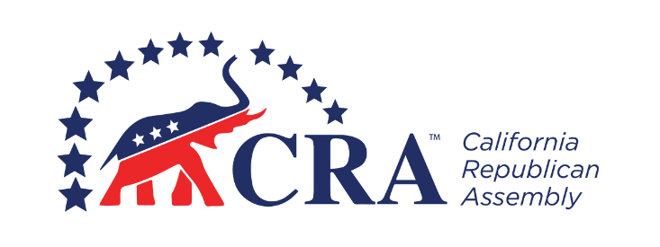
_________________________ Republican Assembly
_______________, 20__ Organizing Meeting

MINUTES

The organizing meeting of the _________________________ Republican Assembly was held on [Date], at [Time], at [Location]. [Name] presided and [Name] recorded the minutes.

Call to Order
[Name] called the meeting to order at [Time].

Opening Ceremonies
[Name] provided the welcoming remarks, [Name] gave the invocation, and [Name] led the Pledge of Allegiance.

Roll Call
Members Present: [List of Members Present]

Guests: [List of Guests in Attendance]

Election of Temporary Chair and Secretary
[Name] nominated [Name] to serve as Temporary Chair. [Name] was elected as Temporary Chair by [acclamation or majority vote].

[Name] nominated [Name] to serve as Temporary Secretary. [Name] was elected as Temporary Secretary by [acclamation or majority vote].

Program
[Name] introduced the guest speaker, [Name and Title], whose subject was the California Republican Assembly.

Ratification of CRA Bylaws
[Name] moved to ratify the Bylaws of the California Republican Assembly. The motion was adopted.

Adoption of Chapter Bylaws
[Name] moved to adopt the Bylaws of the _________________________ Republican Assembly. The motion was adopted [after debate and amendment].

Election of Officers
[Name] nominated [Name] for the office of President. [Name] was elected as President by [acclamation or majority vote].

[Name] nominated [Name] for the office of Vice President. [Name] was elected as Vice President by [acclamation or majority vote].

[Name] nominated [Name] for the office of Secretary. [Name] was elected as Secretary by [acclamation or majority vote].

[Name] nominated [Name] for the office of Treasurer. [Name] was elected as Treasurer by [acclamation or majority vote].

New Business
[Name] moved [Motion]. The motion [passed or failed] with [Number] in favor and [Number] against.

[Name] moved [Motion]. The motion [passed or failed] with [Number] in favor and [Number] against.

Announcements
[Name] announced [Statement].

The next meeting will be held on [Date], at [Time], at [Location].

Benediction
[Name] gave the benediction.

Adjournment
The meeting adjourned at [Time].

[Signature]

[Name], Temporary Secretary

