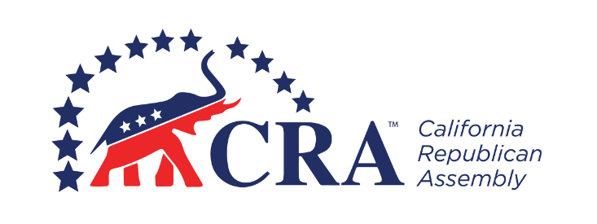
_________________________ Republican Assembly
_______________, 20__ General Meeting

MINUTES

The general meeting of the _________________________ Republican Assembly was held on [Date], at [Time], at [Location]. [Title] [Name] presided and [Title] [Name] recorded the minutes.

Call to Order
[Name] called the meeting to order at [Time].

Opening Ceremonies
[Name] provided the welcoming remarks, [Name] gave the invocation, and [Name] led the Pledge of Allegiance.

Roll Call
Members Present: [List of Members Present from Sign-in Sheet]

Guests: [List of Guests in Attendance from Sign-in Sheet]

A quorum was present.

Program
[Name] introduced the guest speaker, [Name and Title], whose subject was [Topic].

Approval of Minutes
The minutes of the previous meeting were read and approved as [circulated or corrected].

Reports of Officers
President [Name] reported [Statement]. The report required no action and was placed on file.

Vice President [Name] reported [Statement]. The vice president recommended [Motion]. [Name] moved [Motion]. The motion [passed or failed] with [Number] in favor and [Number] against.

Secretary [Name] reported [Statement]. The report required no action and was placed on file.

Treasurer [Name] reported [Statement]. The report required no action and was placed on file.

Reports of Committees
[Committee Name] Chair [Name] reported [Statement]. The committee recommended [Motion]. The motion [passed or failed] with [Number] in favor and [Number] against.

[Committee Name] Chair [Name] reported [Statement]. The report required no action and was placed on file.

Special Orders
[Items designated in the bylaws to be done at a particular meeting such as the election of officers and the selection of delegates to a convention.]

Unfinished Business and General Orders
[Name] moved [Motion]. The motion [passed or failed] with [Number] in favor and [Number] against.

[Name] moved [Motion]. The motion [passed or failed] with [Number] in favor and [Number] against.

New Business
[Name] moved [Motion]. The motion [passed or failed] with [Number] in favor and [Number] against.

[Name] moved [Motion]. The motion [passed or failed] with [Number] in favor and [Number] against.

Announcements
[Name] announced [Statement].

[Name] announced [Statement].

The next meeting will be held on [Date], at [Time], at [Location].

Benediction
[Name] gave the benediction.

Adjournment
The meeting adjourned at [Time].

[Signature]

[Name], Secretary

