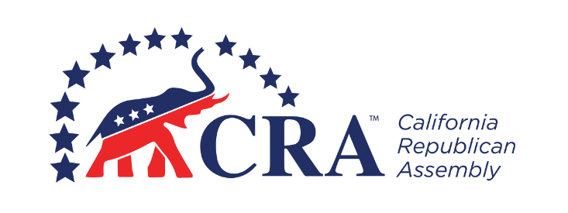
_________________________ Republican Assembly
_______________, 20__ Organizing Meeting

AGENDA

- Call to Order (__:__ pm)

- Opening Ceremonies
- Welcoming Remarks
- Invocation
- Pledge of Allegiance

- Introduction of Elected Officials and CRA Board Members

- Roll Call of Members (New Members and Transfers)

- Election of Temporary Chair and Secretary

- Program
- Presentation: What is the California Republican Assembly?
- Questions and Answers

- Ratification of CRA Bylaws

- Adoption of Chapter Bylaws

- Election of Officers
- President
- Vice President
- Secretary
- Treasurer

- New Business

- Announcements

- Benediction

- Adjournment

Next Meeting: [Date], at [Time], at [Location]

