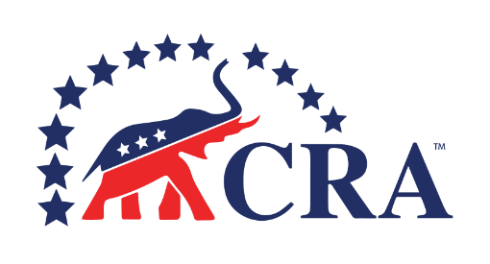

_________________________ REPUBLICAN ASSEMBLY
_______________, 20__ ORGANIZING MEETING

AGENDA

- Call to Order (__:__ PM)

- Opening Ceremonies
- Welcoming Remarks
- Invocation
- Pledge of Allegiance

- Introduction of Elected Officials & CRA Board Members

- Roll Call of Members (New Members & Transfers)

- Election of Temporary Chair & Secretary

- Program: What is the California Republican Assembly?

- Ratification of CRA Bylaws

- Adoption of Chapter Bylaws

- Election of Officers
- President
- Vice-President
- Secretary
- Treasurer

- New Business

- Announcements

- Adjournment

Date, Time & Location of Next Meeting:

